**Name : Wesam Ahmad Dahadha**

**Id :158182**

**____________________________________________________**

( Part 1 )

1. Creates a directory called lab:

mkdir-/lab cd-/lab

2. Create sample files: touch filel.txt file2.sh script.py

3. Tasks:

Check current permissions

Make file2.sh executable

Set script.py permissions: Owner: read/write/execute, Group: read/write, Others: read only

4.Change ownership of filel.txt Assign to a new user student and group students (sudo chown student:students filel.txt)

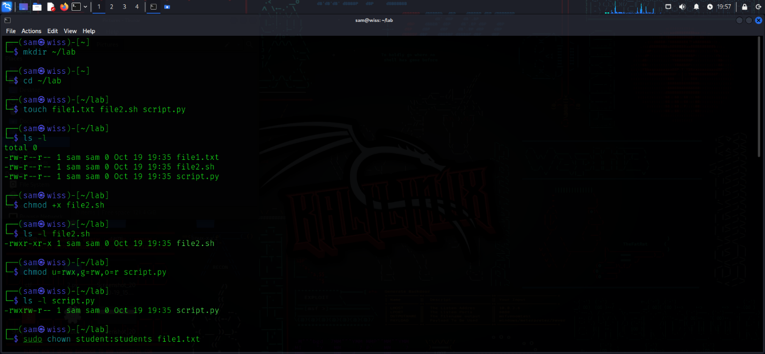

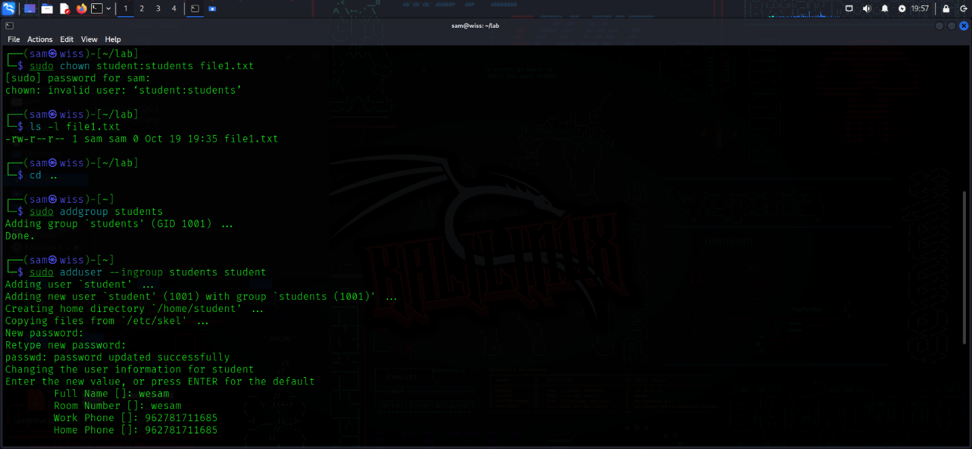

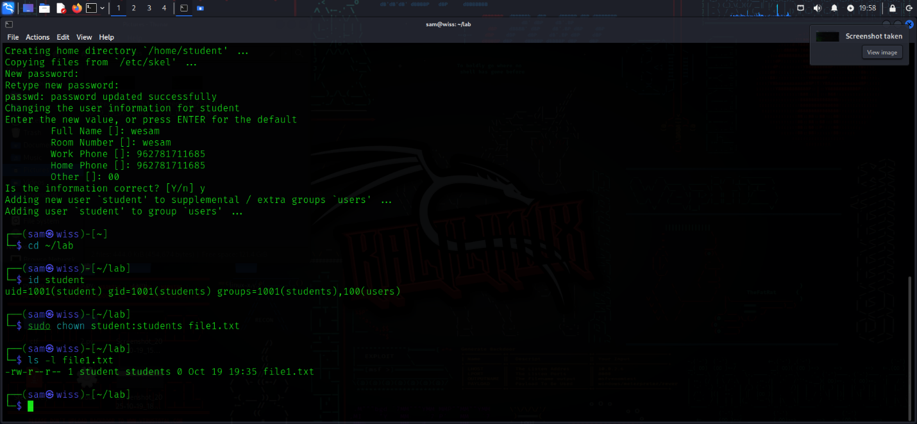

____________________________________________________

(Part 2)

Questions:

What are the permissions of file2.sh now?

-rwxr-xr-x

Who can read/write script.py?

-rwxrw-r--

Owner and group

Which command changes the owner of a file?

chown

How would you make filel.txt read-only for others

chmod o=r file1.txt